Project Development Phase
Model Performance Test
Date | 01 Oct 2026
Team ID | SWTID-2026-4457
Project Name | Script-Controlled ACL – Restrict Record Access Based on Field Value
Maximum Marks | 10 Marks
Model Performance Testing:
A script-controlled ACL returns true (access granted) or false (access denied) for each record. Its performance is measured by how correctly it allows or denies access across roles. Allowed = positive class, Denied = negative class. Test data: 6 records in u_institution_details (2 EEE, 2 ECE, 2 CSE).

S.No. | Parameter | Values | Screenshot
1. | Metrics | Access Test Matrix (records checked per user):  - bb1 user: 2 EEE allowed, 4 non-EEE denied  - User without bb1: 0 allowed, 6 denied  - Admin: 6 allowed, 0 denied  Confusion Matrix:  True Allowed (TP) = 8, True Denied (TN) = 10  False Allowed (FP) = 0, False Denied (FN) = 0  Accuracy Score = (TP+TN)/Total = 18/18 = 100%  Classification Report: Precision = 1.00, Recall = 1.00, F1-score = 1.00 (both classes) | bb1 user list (only EEE records)  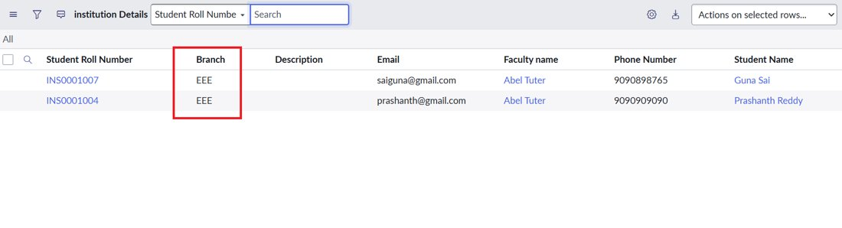  User without role (No records to display)  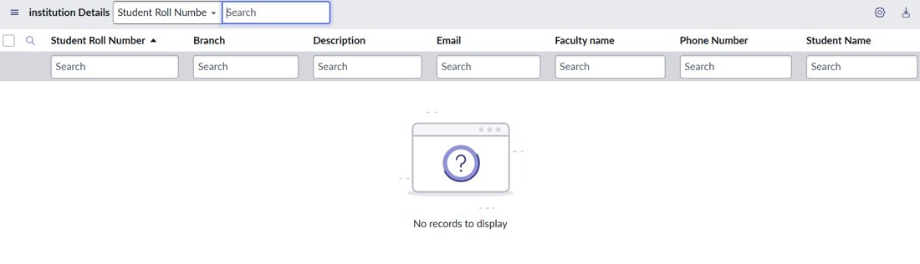  Admin list (all 6 records)  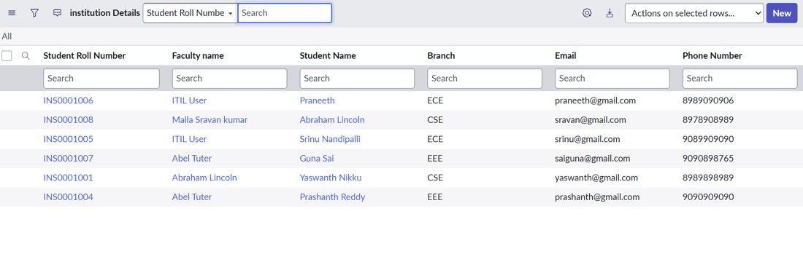
2. | Tune the Model | Hyperparameter Tuning (ACL tuning):  - Script refined from separate admin/bb1 checks to a single role check: gs.hasRole('bb1') returns true, else false  - Data condition Branch is EEE added so the script is evaluated only for EEE records  - Role requirements split per operation: Read = bb1, Create = bb2, Write = bb3, Delete = bb4  - Admin overrides enabled for full admin access  Validation Method: Role-based impersonation testing – impersonate the EEE User (bb1–bb4), a user without roles, and Admin, then compare the visible records and available actions (New, edit, Delete) with the expected results. | ACL record (Read, Advanced enabled)  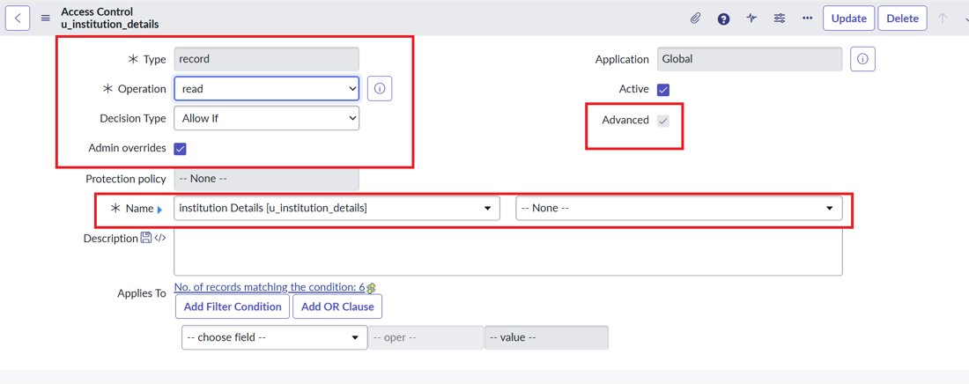  Data condition (Branch is EEE) and script  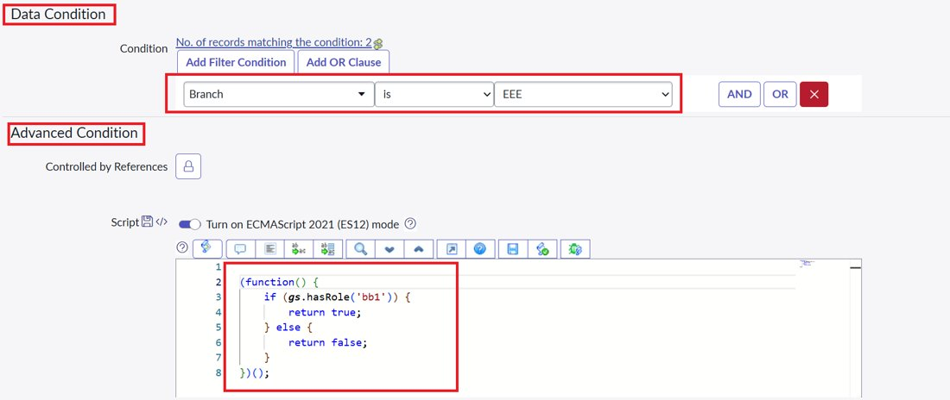  Create ACL – role bb2  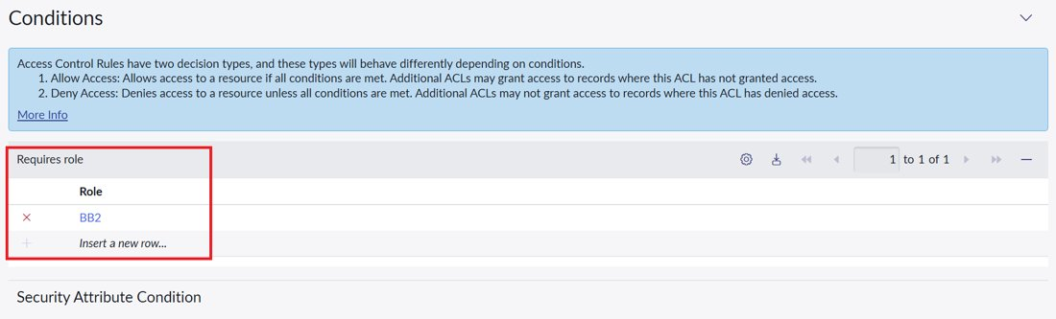  Write ACL – role bb3  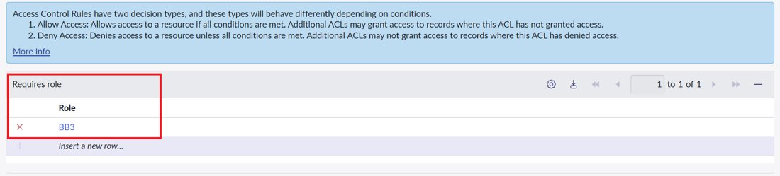  Delete ACL – role bb4  